West Virginia Division of Forestry Urban and Community Forestry

Community EquiTree Grant Instructions

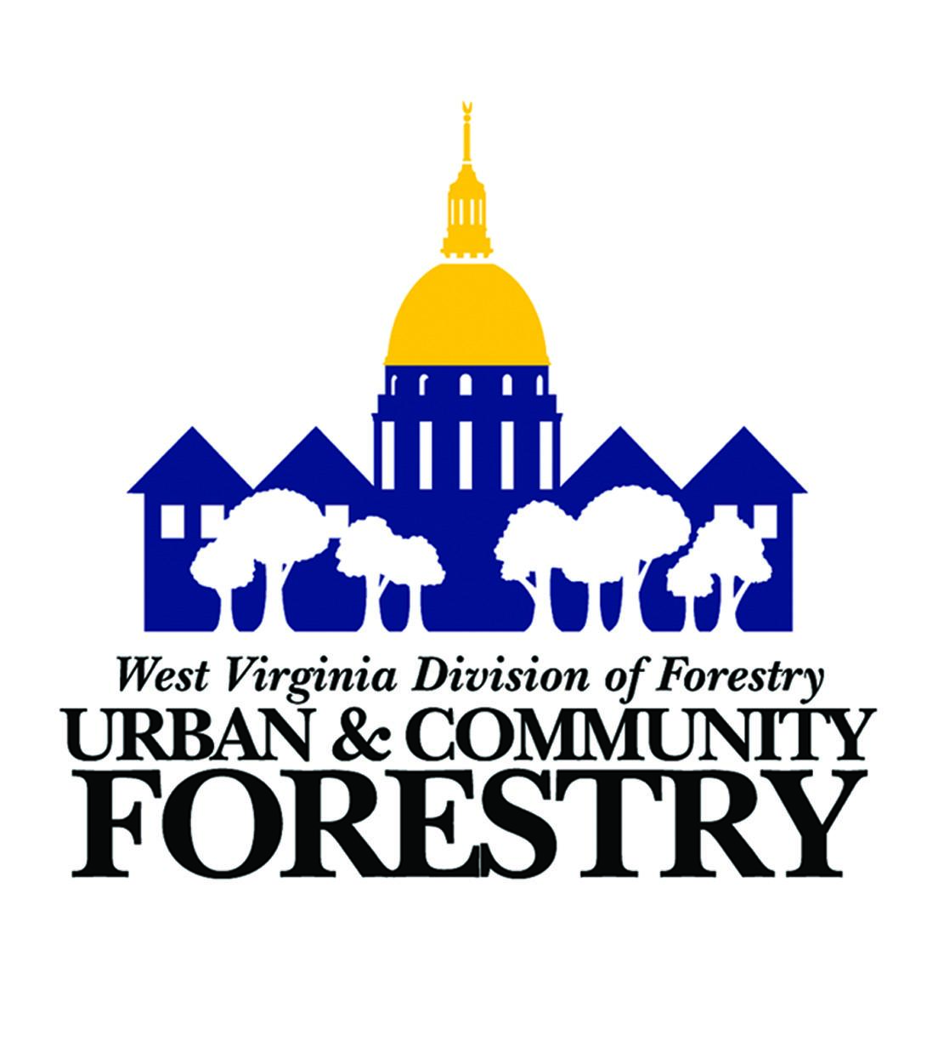

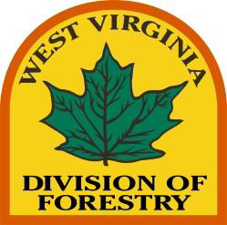

Grant program administered by the WV Division of Forestry (WVDOF) with funding appropriated to the USDA Forest Service Urban and Community Forestry (UCF) Program through the Inflation Reduction Act (IRA). This institution is an equal opportunity provider.

Community EquiTree Grant
West Virginia Community EquiTree (CET) Grants promote urban tree planting and other urban forestry projects on public property within communities and neighborhoods that are federally designated as disadvantaged. Federally disadvantaged communities are determined by the Climate and Economic Justice Screening Tool (CEJST) (see the separate “Instructions for using the Climate and Economic Justice Screening Tool” for more details). The primary objectives of this program are to provide municipal governments and other public entities with funding to increase canopy cover in communities with few trees, improve human health and build the capacity of municipal tree care efforts.

This is a competitive grant program available to municipalities, public schools and nonprofits with a focus on the management of urban trees on public lands. The maximum grant request per application is $50,000. However, all requests must be realistic and proportional to the size and scope of the project and community. This is a reimbursement grant that requires the applicant to expend related funds up front then submit invoices upon completion for reimbursement. Reimbursements can be made quarterly for portions of the grant completed to date. Applications will be scored and ranked against other applications received during the same grant cycle with the highest ranked applications being funded. Tree City USA communities and those working towards that goal will be prioritized. This grant is 100% focused on federally designated disadvantaged communities and consequently will not require applicants to provide matching funds. Proposal requirements, deadlines, and information on how to apply are described below. After reading the application groups are encouraged to contact us with any questions or concerns during the planning phase for their proposal.

Community EquiTree Goals
Enhance canopy cover in communities currently with low canopy cover through large-scale tree plantings on public property.
Increase access to trees and canopy in disadvantaged communities while improving the quality of life in these communities.
Improve human health with plantings that enhance air quality by utilizing tree canopy to filter and reduce airborne pollutants.
Build capacity in communities with existing long-term tree care programs while fostering sustainability in communities not currently managing their urban forest through the formation of tree boards and adoption of tree ordinances and budgets.
Increase access and awareness through enhanced outdoor recreation opportunities such as interactive community tree walks and other links to green spaces.

Eligible Entities
Municipal, County, Regional, State, Public Governments
Public Primary, Intermediate, and Secondary Schools
Public Higher Educational Institutions
Non Profit Organizations that are or can become Registered Vendors with the State of West Virginia and with prior experience planting or maintaining trees on public lands or urban forestry - note: vendor registration must be completed by the time grant applications are evaluated

Eligible Disadvantaged Communities
Grant projects must only occur in federally designated disadvantaged areas. Federally disadvantaged census blocks are determined by the Council on Environmental Quality's Climate and Economic Justice Screening Tool (CEJST). See instructions in the separate “Instructions for using the Climate and Economic Justice Screening Tool (CEJST)” document to determine eligibility for Urban Canopy EquiTree grant funds. It is possible for some areas within a single municipality to be eligible while other parts of the city are ineligible. It is important to determine eligibility before planning a grant project.

Eligible Projects
All grant projects must occur on public property. We encourage applications that involve the following projects on located in federally disadvantaged communities as determined by the Climate and Economic Justice Screening Tool (CEJST) https://screeningtool.geoplatform.gov/en/#3/33.47/-97.5
Planting trees on public lands, particularly those that improve human health in areas of low canopy cover by mitigating extreme heat and/or enhancing air quality through the filtering of airborne pollutants.
All plantings must involve a minimum of 3 tree species and plantings of more than 50 trees must utilize a minimum of 5 species to avoid creating a monoculture.
All applications involving tree planting must include a map of the planting area(s) that show relevant features such as roads, sidewalks, buildings, overhead utility lines and tree locations. Applicants are encouraged to use Google My Maps which is free with a Google account: https://www.google.com/maps/d/
Designing, planting trees and educational materials for community tree walking paths especially those that increase access to public recreation areas such as parks and other trail networks.
High-value tree care such as pruning, vertical mulching, tree health assessments and remediation.
Hazard tree mitigation and removal - replanting within affected communities at a minimum of 1:1 is required. Only dead or high risk of failure trees are eligible for removal with grant funds. The method and threshold by which trees are defined as hazardous or high risk should be clearly outlined in the application.
Public tree inventories and management plans entirely in federally disadvantaged (CEJST) areas, must include a second phase involving tree planting. Inventories and plans that involve portions of a municipality outside non federally disadvantaged (CEJST) areas need to include significant and documented community engagement and include strategies for improving services to disadvantaged communities.
Tree planting as part of green infrastructure projects that reduce stormwater runoff - note: grant funds can not be used for construction retention ponds, rain gardens, etc. but can be used to plant trees in water control structures.
Equipment costing less than $5,000 and having a clear and unique connection to the planting or care of urban trees - note: general use equipment such as lawnmowers, trimmers, chain saws, etc. are not eligible equipment purchases. $5,000 is the maximum amount per application for equipment.
Salaries for the workforce development training of municipal employees to become International Society of Arboriculture (ISA) Certified Arborists or student internships specific to urban forestry where the student is receiving training and gaining diverse experience from a professional arborist or forester.
Contracting with or employment of (ISA) Certified Arborists and WV Registered Professional Foresters to provide professional urban forestry management within a municipality. Grants involving salaries must demonstrate capacity building such as the contracting leading to the future hiring of a city arborist or forester.
Design and development of urban wood utilization programs.
Designing or providing trees and plants for urban food forests and orchards.
Other projects directly involved with the management and care of public trees within an urban forest.

Ineligible Projects
Any grant projects outside federally disadvantaged census tracts as determined by the Climate and Economic Justice Screening Tool (CEJST) or on private property are not allowed. No portion of the grant can be used for:
Administrative costs
Staff salaries are not permitted, with the exception of student internships or the training and/or contracting with ISA Certified Arborist and WV Registered Professional Foresters working as a municipal arborist or forester.
Any type of construction including paving, sidewalks, buildings of any type, utilities, earth moving (with the exception of tree planting), ponds, etc. can not be funded.
Equipment costing more than $5,000 and not uniquely used for the planting or maintenance of urban trees.
Canopy cover assessments.
Purchasing land or any real estate charges.

Grant Requirements
Maximum grant request per application is $50,000 and requests must be realistic and proportional to the size and scope of the project and community.
Applicant must be a Registered Vendor with the State of West Virginia.
Applicant must be registered at SAM.gov and provide a valid Unique Entity Identifier (UEI).
Applicant must have completed Financial Capability Questionnaire on file with the WVDOF.
Applicant must complete all acknowledgements and certifications in the application.
Only one application per entity per grant cycle is allowed.
All grant funds must be expended on public property (town squares, schools, parks, road right-of-ways, etc.) and be within a disadvantaged community as identified by CEJST.
Ability to describe a strong statement of need, short and long-term goals and provide a detailed project budget.
Must solicit and include at least two verbal bids for all purchases above $10,000. (See Bidding Requirements below)
Ability to describe the detailed scope, benefits and outcomes of the project.
Document the social and environmental benefits of their tree planting or project.
Provide a planting plan, species list, itemized costs and map(s) of planting sites for grants involving tree planting.
Provide a detailed budget with itemized unit prices that’s described in project narrative.
For projects involving more than tree planting, provide sufficient details of objectives, contractors involved, specific work performed and outcomes and results.
Ability to enter into an agreement with the WVDOF for the grant funds including completing USDA certification forms and be a Registered Vendor with the State of West Virginia before grants are awarded.
Any previous Community Equi-Tree grants must be completed and submitted for reimbursement prior to submitting an additional application. Any entity with an open agreement for a CET grant may not apply for additional funding.
Ability to complete the entire grant project within the time specified in the agreement. The time frame is negotiable and will typically be two years.
Ability to pay the cost of grant invoices up front and apply for reimbursement upon completion.
Budget and capacity to maintain all trees planted and other grant projects for a minimum of five years.
The USDA Forest Service and Inflation Reduction Act will be acknowledged as a funding source for work performed under this grant, including any future signage requirements.

Bidding Requirements
Grant recipients are required to follow the federal procurement standards regarding allowable costs, procurement standards, bidding, etc. as described in 2 CFR 200 which can be found here: https://www.ecfr.gov/current/title-2/subtitle-A/chapter-II/part-200#subject-group-ECFR45ddd4419ad436d
Purchases under the Micro-Purchase threshold (currently $10,000) do not require bids.
Purchases above the Micro-Purchase threshold and below the Simplified Acquisition Threshold, which is defined as $250,000, should follow the small purchase procedures. The federal 2 CFR 200 regulations state for small purchases “price or rate quotations must be obtained from an adequate number of qualified sources as determined appropriate by the non-Federal entity.”
These rate quotations may be verbal which involves calling/visiting two or more vendors and completing the separate Urban Forestry Verbal Quotation Summary form to document prices.
Written bids from two or more contractors are also acceptable but formal written bids are not required.
Copies of two or more quotations for all purchases over $10,000 must be submitted with the Community Equi-Tree application.
Applicants are not required to utilize the low bid for small purchases below the Simplified Acquisition Threshold (less than $250,000). The federal 2 CFR 200 regulations state “Contracts must be awarded to the responsible offeror whose proposal is most advantageous to the non-Federal entity, with price and other factors considered.”
If the low bid is not utilized, rationale for selecting a higher bid must be articulated in the Reason for Award at the bottom of the Urban Forestry Verbal Quotation Summary or attached to written bids.

Reimbursement Requirements
This is a reimbursement grant that requires the recipient to expend local funds up front then submit required invoices and documentation for reimbursement.
Payment will only be made to the grant applicant listed on the agreement and not to any contractor(s) performing work on the project.
All work must be completed by the ending date on the agreement. All final invoices and documentation must be submitted for reimbursement no later than 30 days after this date.
Reimbursement can be made quarterly but only for portions of the project that have been completed and paid by local funds. This will require invoices with proof of payment to the contractor(s).
Invoices submitted to the WVDOF for reimbursement must be on contractor letterhead, itemized, and contain unit prices. Copies of checks or other proof of payment is required.
The WVDOF will require a site-inspection and all trees must be planted in accordance with the Tree Establishment Specifications before payment can be made.
To begin the reimbursement process, all required expenditure documentation must be submitted along with an invoice of grantee letterhead for the reimbursement amount to:
DOFUrbanForestry@wv.gov

Application Components and Dates
All applications must be of the required application forms - additional sheets can be attached
Cover Sheet (5 Points)
Organization and Statement of Need (30 Points)
Short and Long Term Goals (5 Points)
Project Description and Planting Map (30 Points)
Budget (20 Points)
Signed Tree Establishment Specifications Waiver (5 Points - automatic if not planting trees)
Signed Tree Maintenance Form (5 Points - automatic if not planting trees)
Only complete and signed applications will be considered
Applications must be submitted by email to: DOFUrbanForestry@wv.gov
Grant Dates are as follows:
Application submission deadline - May 31, 2024 Applications Due (COB 4:30pm)
Applicants notified of funding status by - July 19, 2024
Grant agreements and forms sent to successful applicants - August 2, 2024
Signed grant agreements and forms return date - August 16, 2024
Grant projects may begin after notification and finalized agreements are processed and returned to the applicant.

Rating Criteria
Proposals will be evaluated and scored by WVDOF Urban Forestry staff and a UCF awards committee using the criteria below.
Cover Sheet (5 Points)
Organization and Statement of Need (30 Points)
Short and Long Term Goals (5 Points)
Project Description and Planting Map (30 Points)
Budget (20 Points)
Signed Tree Establishment Specifications Waiver (5 Points - automatic if not planting trees)
Signed Tree Maintenance Form (5 Points - automatic if not planting trees)
Tree City and Campus USA will receive 10 extra credit points
Communities that are not TC USA’s can still receive partial extra credit points by documenting an active tree board or other volunteer based public tree care group (5 extra credit points)
Communities that are not TC USA’s can still receive partial extra credit points by documenting a comprehensive and enforced public tree ordinance (5 extra credit points)

APPLICATION TIPS
Read all directions! Make sure your proposal includes all necessary components. Only complete applications will be considered.
It is highly recommended that applicants email WVDOF Urban staff to discuss their proposal before developing an application at: DOFUrbanForestry@wv.gov
Chris Bodkin, EquiTree Grant Specialist, is available for technical assistance and proposal development at:wvuequitree@gmail.com
Verify eligibility! Use CEJST to determine eligibility and provide sufficient details on the location to allow for verification at: https://screeningtool.geoplatform.gov/en/#3/33.47/-97.5
Pay very close attention to the points system as it will give indication of which application components we value the most.
Be creative! Think outside the box and have fun! Preference will be given to proposals that encourage citizen engagement and are inclusive of the entire community.
Be specific! The narrative should be easy to read, clearly written, and should present your ideas in a concise, yet sufficiently detailed manner.
Preference will be given to groups that clearly demonstrate your community’s need and how the goals of your project align with the overall goals of Community EquiTree.
Follow through! Subsequent funding will only be available to groups that demonstrate commitment to successfully complete a grant project and follow the tree maintenance requirements.

